**Project Development Phase**

**Model Performance Test**

|  |  |
| --- | --- |
| Date | 10 NOvember 2022 |
| Team ID | PNT2022TMIDxxxxxx |
| Project Name | Project - xxx |
| Maximum Marks | 10 Marks |

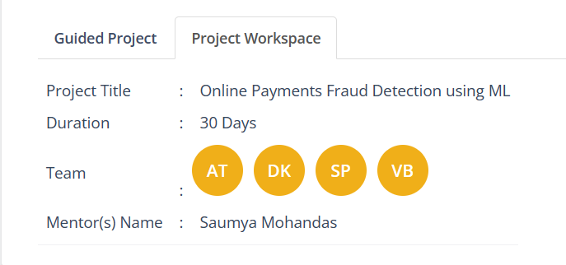

**Model Performance Testing:**

Project team shall fill the following information in model performance testing template.

|  |  |  |  |
| --- | --- | --- | --- |
| **S.No.** | **Parameter** | **Values** | **Screenshot** |
|  | Metrics | **Regression Model:** MAE - , MSE - , RMSE - , R2 score -  **Classification Model:** Confusion Matrix - , Accuray Score- & Classification Report - |  |
|  | Tune the Model | Hyperparameter Tuning -  Validation Method - | No hypertuning or validation methods used |